Online account forgot username and password reset instructions
- If you have forgotten your username or password, from the online registration site, click the “login” button.

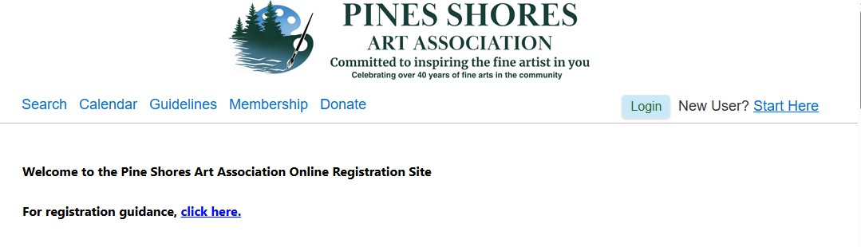

- Scroll down the login page to the section labeled “Forgot your username and password?” Next, select the “Click here to reset” link.

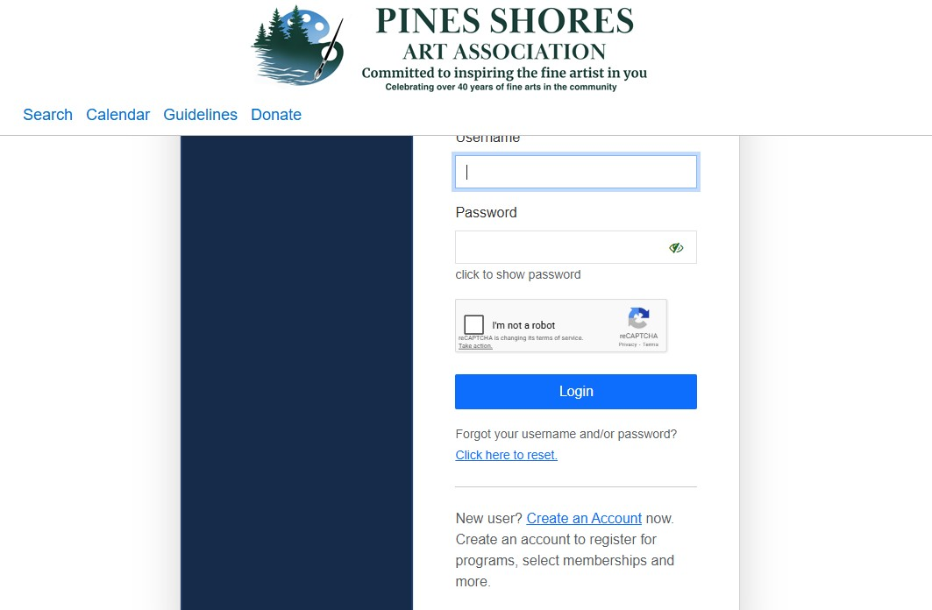
- Enter the email address on record for your account. Then select the “submit” button.

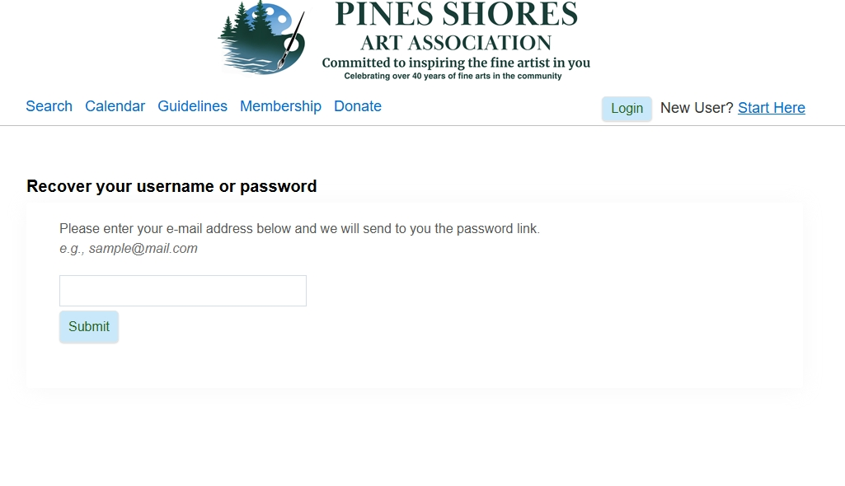
- An email will be sent to your account. Go to your email account. The link in the email is good for 30 minutes.

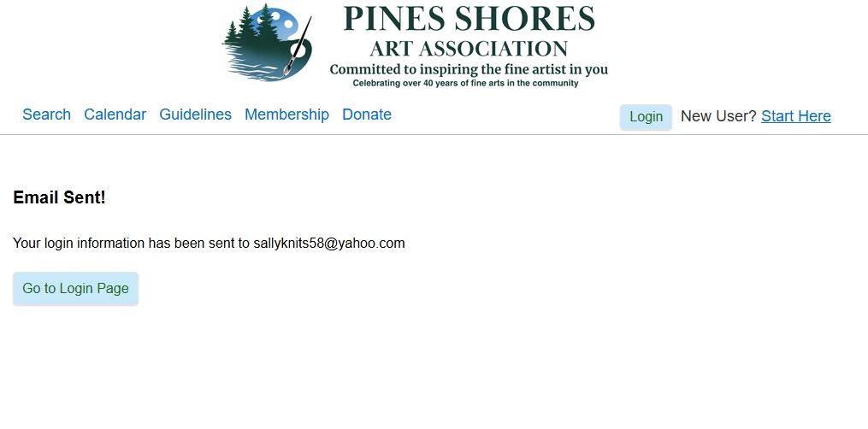
- Sample Email. Using the “click here” link in the email will take you to the password reset page.
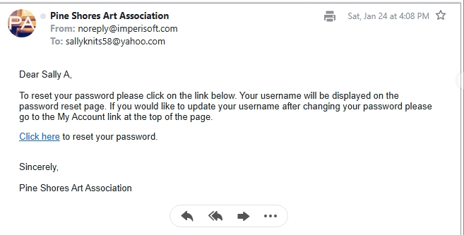

- Username and Reset Password Page
- If you forgot your username, it will be displayed on the “reset password” page (sample below).
- If you forgot your password, you could reset it here.
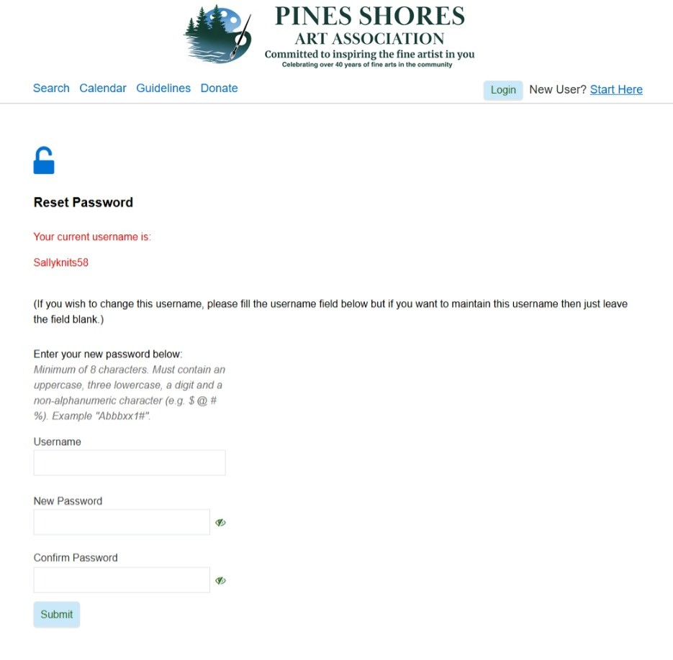
Use your existing username OR create a new username here. Be sure to note your username and new password for future use.
Use this Username to reset your password
- Once your password is reset, you will be logged on and redirected to the search page.

